EXPERIMENT – 2.

Configuration of topologies using Packet Tracers(Star , Mesh , Tree).

1. Star topology.

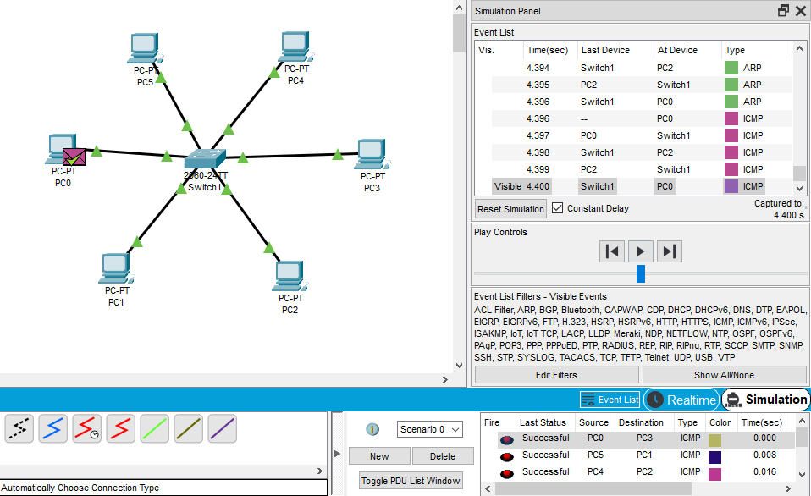

1. Mesh Topology

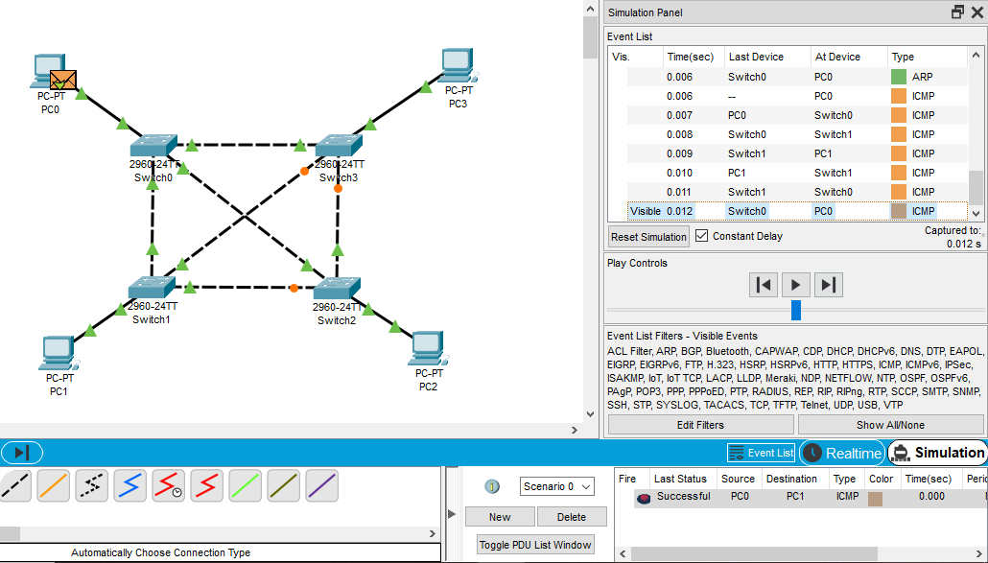

1. Tree Topology.

